ADVANCED PROGRAMMING (OBJECT ORITNETED PROGRAMMING)

TITLE : SIMPLE 2D PLATFORMER GAME

NAME: SOHAM CHOWDHURY

ROLL:35

INSTRUCTOR: PROF. SWAGATAM BASU

PROF.SOUMADIP BISWAS

SPRING 2026

PROBLEM STATEMENT
This project was made to simply demonstrate how a basic game logic would be made in java without the help of any engine. It focuses on the usage of basic keywords and packages to perform the tasks for game loop, animation cycling and User input.

This project focuses on games what would run on lightweight platforms as game engines are heavy in most scenarios. It uses the basic knowledge of JAVA and applies that to a character that can move with the help of keyboard input.

SYSTEM DESIGN

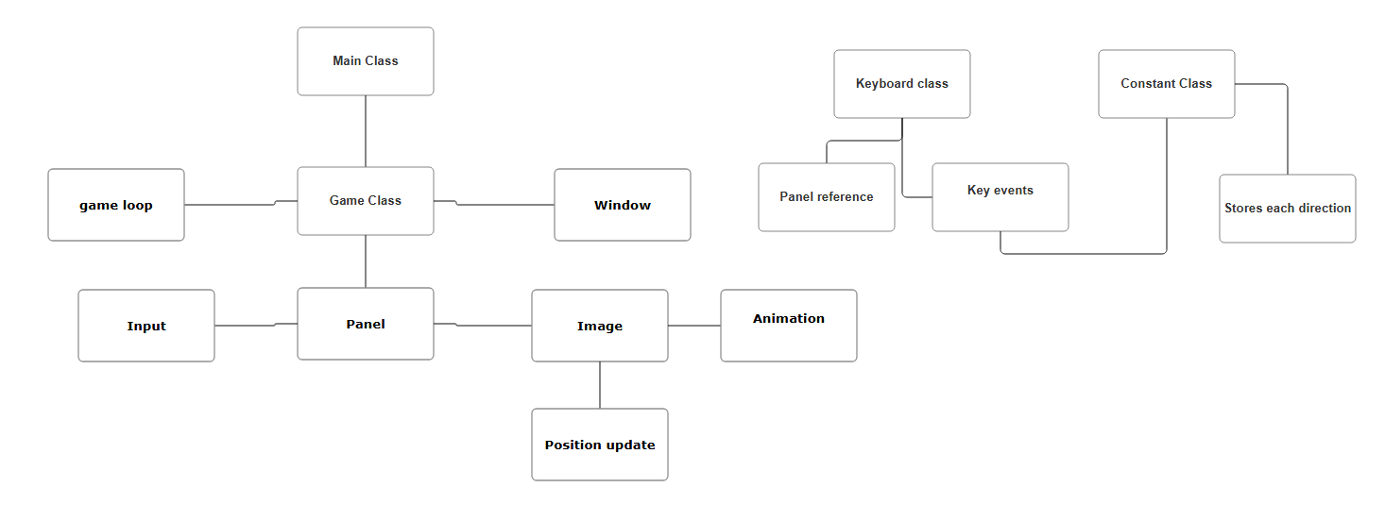

CONCEPTS DEMONSTRATED
Inheritance : “public class Panel extends Jpanel” shows that the Panel class is inheriting everything from Java's built-in javax.swing.JPanel class. Using this we can use the Jpanel feature on the get go.
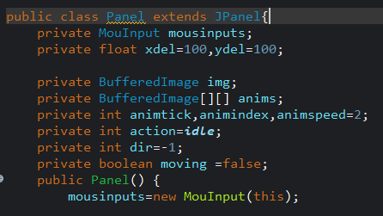
Polymorphism: ‘’public void paintComponent(Graphics g)’’ shows that we are overriding the paint component method. When the Java system refreshes the screen, it polymorphically calls my custom version of paint component instead of the default one. Keyboard(), addKeyListener(), also contribute to polymorphism.
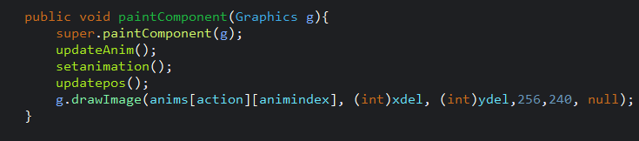
The Jpanel contains the game window . The Paint component draws the image or the sprite on the screen. The sprite sheet contains a lot of images that are to be used in rotation to create an animation . The paint component traverses through a 2D array of indexes and paints the required amount of drawings for a particular animation.

The importimg() method finds the image from the resource folder , reads it and stores it in the img variable. It uses an IOException to catch any unwanted errors when the picture isn’t properly addressed.

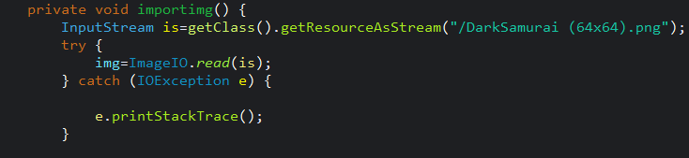
IMPLEMENTATION HIGHLIGHTS

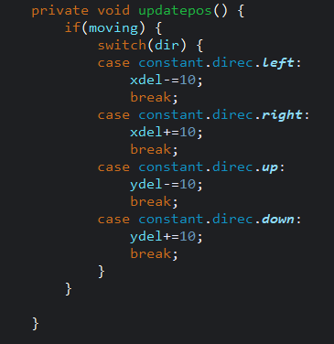
updatepos() is basically the brain that decides where our samurai character should stand on the screen in the next frame.
Think of it like this: our character has a set of coordinates, xdel (horizontal) and ydel (vertical). Without this method, our samurai would just be a static image stuck at 100, 100 forever.

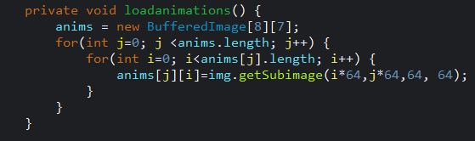
Think of loadanimations() as the cutting phase of the game.
Right now, we have one big image that contains every single frame of animation for our character such as walking, idling, attacking, etc. If we just drew that one big image, our character would look like a giant sheet of postage stamps.
loadanimations() cuts that sheet into individual frames and organizes them so the game can play them back like a flipbook.

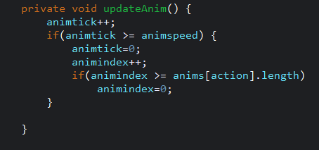
updateAnim() is the metronome for our character's flipbook. If we didn't have this, our samurai would either stay on a single static frame or change frames so fast (60 times a second) that he would look like he was vibrating. It controls the speed or the animation and the length of it.

GIT WORKFLOW

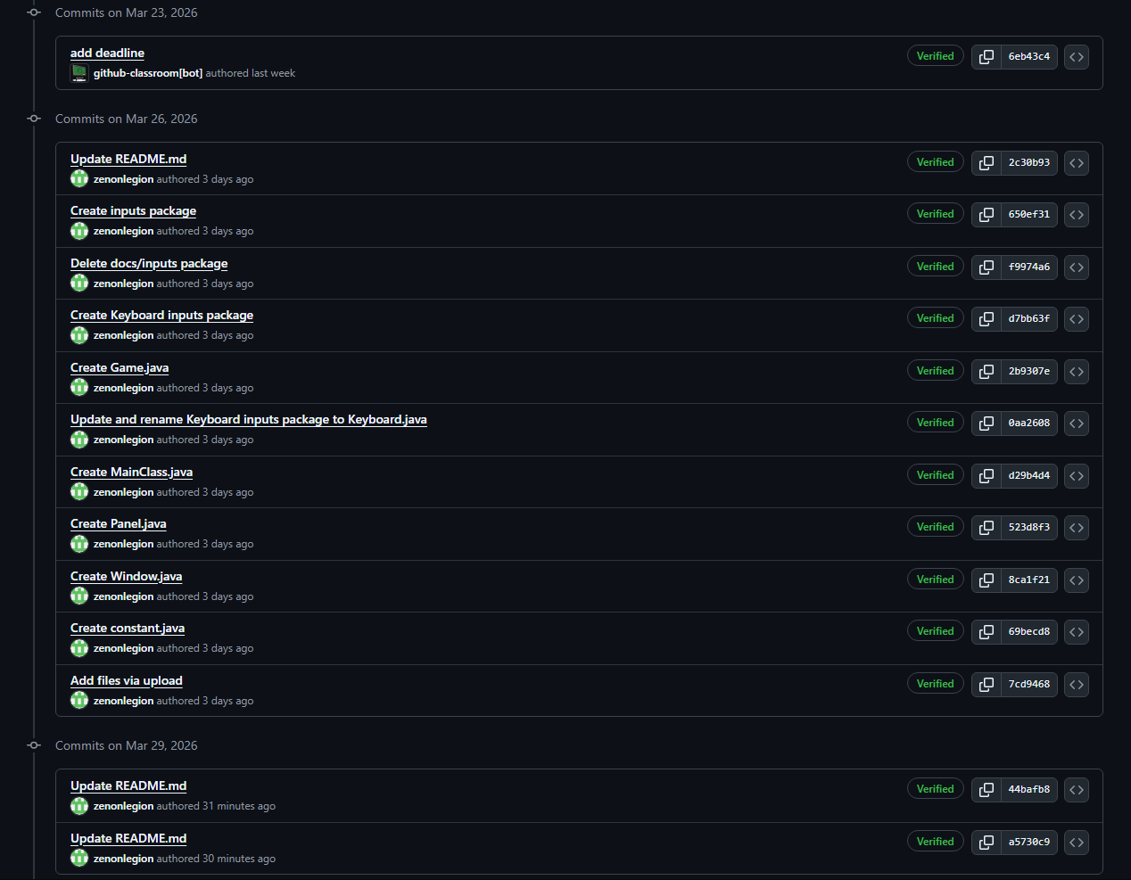

I built the small, necessary pieces inputs, constants first, then wrapped them into the larger systems Panel, Window, and finally the Main Class. It is a very logical, organized way to code because it ensures every part works before the whole is put together.

CONCLUSION

I managed to take a single sprite sheet and turn it into a living, moving character using Java. It’s not just about making a samurai walk around a screen though it’s about actually seeing how those big OOP concepts like inheritance and abstraction work in a real game instead of just reading about them in a textbook.

Building the game from scratch was a bit of a grind, especially getting the animation timing right and sorting out the folder structures, and getting it to work. Now that the skeleton is done and the character is moving, I have got a solid foundation to start adding the actual elements such as enemies, combat, and many more physical features that could be done. It's a solid first step and I am eager to implement more java features to improve the responsiveness and look of the game. This game is still a work in progress and can be improved further.

